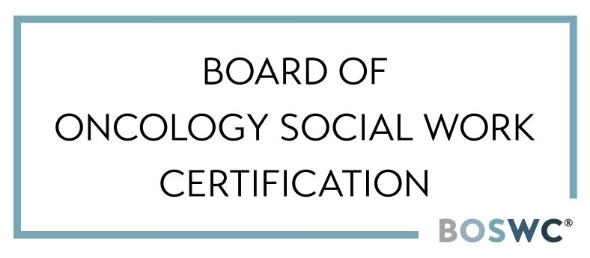
2026 AOSW Annual Conference
BOSWC® / OSW-C® Competency Domains
Session Attendance Checklist
June 10-12, 2026 | Portland, Oregon

Attendee Name: ___________________________________________________

Check if attended & indicate # of CEUs | Session Name | OSW-C Domain(s)
 | Addressing Financial Toxicity Beyond Financial Assistance: Practical Strategies for Oncology Social Workers | 2, 4
 | Addressing Systemic Barriers and Unmet Needs in Marginalized Cancer Patients | 1, 2, 3
 | Advanced Clinical Case Conceptualization to Deliver Psychotherapies to Individuals Impacted by Cancer | 1, 2
 | Aligning Prognostic Understanding: A Couple’s Based Approach for Oncology Social Work | 1, 5
 | Among the Trees: Integrating Therapeutic Nature-Based Interventions in Cancer Care | 1, 5
 | An Existential Toolkit: What Cancer Care Teaches Clinicians About Living | 1, 5, 6
 | At the Heart of Care Alignment: Oncology Social Work as Listener, Guide, and Advocate | 1, 2, 4
 | Awestruck: The Transformative Power of Wonder in Psychosocial Oncology (PART 1) | 1, 5
 | Awestruck: The Transformative Power of Wonder in Psychosocial Oncology (PART 2) | 1, 5
 | Beyond the Clinic: An Innovative Partnership to expand access to oncology counseling services | 2, 5
 | Body Image After Cancer: Body Positive Interventions for the Oncology Setting | 1, 2, 4
 | Bridging Cultures: Empowering oncological care | 1, 2, 4
 | Bringing Art Into Practice: Integrating Photovoice as a Tool for Enhancing Survivors' Existential Quality of Life | 1, 5
 | Building Psychological Resilience through stress management skills | 1, 5
 | Confronting Racism in Healthcare: Building an Anti-Racist Clinical Practice Through Self-Reflection, Education, and Healing | 1, 2, 3
 | Creating Engaging and Psychologically Safe Virtual Experiences for the Person Behind the Pixel | 1, 5, 6
 | Creating Psychosocial Support for Spouses and Partners of Young Adult Cancer Patients | 2-6
 | Cultivating Resilience and Connection in Remote Oncology Social Work Teams | 5, 6
 | Emerging Adults and Advance Care Planning: How social workers can support what matters most | 1, 2, 4
 | Expanding Supportive Care for Family Caregivers: Adapting the Healthy Communication Practice to Target Caregivers' Distinct Needs and Reduce Distress | 1, 4, 5
 | Facing the In-Between: A Survivor-Social Worker Conversation on Grief and Healing | 1, 3
 | Fostering Resilience in Cancer with DBT-Based Skills (PART 1) | 1
 | Fostering Resilience in Cancer with DBT-Based Skills (PART 2) | 1
 | From Concept to Practice: Cultivating Vicarious Resilience and Professional Sustainment Through Mentorship and Supervision in Oncology and PELC | 5, 6
 | From Then to Now: Social Work's Enduring Legacy in Times of Upheaval (PART 1) | 3, 6
 | From Then to Now: Social Work's Enduring Legacy in Times of Upheaval (PART 2) | 3, 6
 | Goodbye Dr. Google, Hello AI: Oncology Social Workers as Leaders in Supporting Patients Navigating AI | 1, 3, 4
 | Healing Through Compassion: The Journey of Building a Self-Compassion Program for the Cancer Experience | 1, 5
 | Helping Patients Deal with Changes in Memory, Thinking, and Focus Due to Cancer Related Cognitive Impairment (aka "Chemo Brain") | 1, 4
 | I Have a Secret: The role of social work in serious illness | 1, 2, 4
 | Increasing Palliative Care Referrals Through Interdisciplinary Collaboration and Machine Learning: Findings from a Three-Month Pilot | 2, 4, 5
 | Leaving a Lasting Legacy: Connecting the past, present and future with social work interventions during end-of-life care | 1, 2, 4
 | Lights, Camera, Action! Implementing Cognitive Behavioral Therapy Practices | 1, 2
 | Lowering the Threshold, Raising the Reach: Virtual Strategies to Strengthen Behavioral Health in Oncology Settings | 1, 2, 5
 | Making Space in the Bedroom: Inclusive Analytic Processing Groups for Sexual Recovery Among LGBTQ+ and Relationally Diverse Survivors | 1, 5
 | Non-Ordinary States of Consciousness in Oncology Social Work: Preparation & Integration for Life-Changing Diagnoses | 1, 3, 5
 | Nourishing Body & Mind—Integrating Self-Compassion, Nutrition, and Psychosocial Support in a Virtual Group Setting | 1, 2, 5
 | Oncology Social Work Foundations: Learning to Manage Complex Needs and Foster Connections | 1, 2, 4, 6
 | One Less Lonely Group: Improving Program Attendance through Innovative Delivery Methods, Changing Group Structure, and Thinking Outside the Box | 2-6
 | Optimizing Sexual Recovery of Prostate Cancer Patients and their Partners: Implementing the International Guidelines for Sexual Health Care after Prostate Cancer Treatment in Oncology Social Work Practice (PART 1) | 1, 4
 | Optimizing Sexual Recovery of Prostate Cancer Patients and their Partners: Implementing the International Guidelines for Sexual Health Care after Prostate Cancer Treatment in Oncology Social Work Practice (PART 2) | 1, 4
 | Positioning Social Work at the Core of Supportive Oncology Collaborative Care | 1, 2, 4, 5
 | Principal Illness Navigation in Action: Strengthening Social Work's Role in Oncology | 2, 3, 5
 | Restoring Purpose: The Role of Meaning-Centered Psychotherapy in Allogeneic Hematopoietic Stem Cell Transplant Recovery | 1, 5
 | Rooted, Not Hardened: How Struggle Shapes Us | 5, 6
 | Solidarity in the Shadows: Resilience and the Role of Affinity Groups for Latinx Oncology Social Workers Navigating Immigration-Related Patient Distress | 2, 3, 5
 | Strengthening Psychosocial Care Pathways in Oncology: Collaborative Models for Comprehensive Patient Support | 1, 2, 4, 5
 | Supporting Mental Health in Young Adults with Cancer: Strategies for Oncology Social Workers | 1, 2, 3
 | The Art of Close Listening: Honoring Stories of Illness Through the Practice of Narrative Medicine | 1, 6
 | The CALMM Intersection: Weaving Resilient Systems and Breaking Barriers in Oncology Social Work | 1, 2, 3, 5
 | The Goals-of-Care Loop: Why Teams Get Stuck and How Oncology Social Workers Restore Alignment | 1, 2, 4
 | The Journey of Care for Rural Esophageal Cancer Patients | 1, 2, 5
 | The Paradox of Being “Cured”: Disenfranchised Anticipatory Grief and Mortality Contemplation in Curable Cancer Care | 1, 2, 4
 | The Pay Isn’t Great, but the Existential Dread Is Free: Reflections on Trauma, Purpose, and Oncology Social Work | 5, 6
 | Trauma, the Body, and Healing in Cancer Care | 1, 3, 4
 | Walking Together: How Relationship and Mutual Learning Guided Psychosocial Program Adaptation with Navajo Communities at the House of Hope | 1, 2, 5
 | Who Lives, Who Dies, Who Tells Your Story? Documentation As a Tool for Storytelling in The Age of A.I. and Open Notes | 1, 2, 3, 4
 | Yes You Can! Addressing Sexual Wellness in Short-Tern Oncology Counseling/Support | 1, 2, 4

Please upload this completed document with your conference CEU certificate which indicates the number of CEUs earned for BOSWC OSW-C application/renewal.

I verify that I have attended these sessions and completed evaluation for CEU.

Signature/Date: ____________________________________________________________

